**Web Scraper**

**Building the Knowledge Base:**

My knowledge base is relatively simple since it’s just a python dictionary that I pickled. The dictionary has each of my top ten terms as a key and their values are the sentences that contain that term. So, the ‘bob’ key has all the sentences that contain ‘bob’.

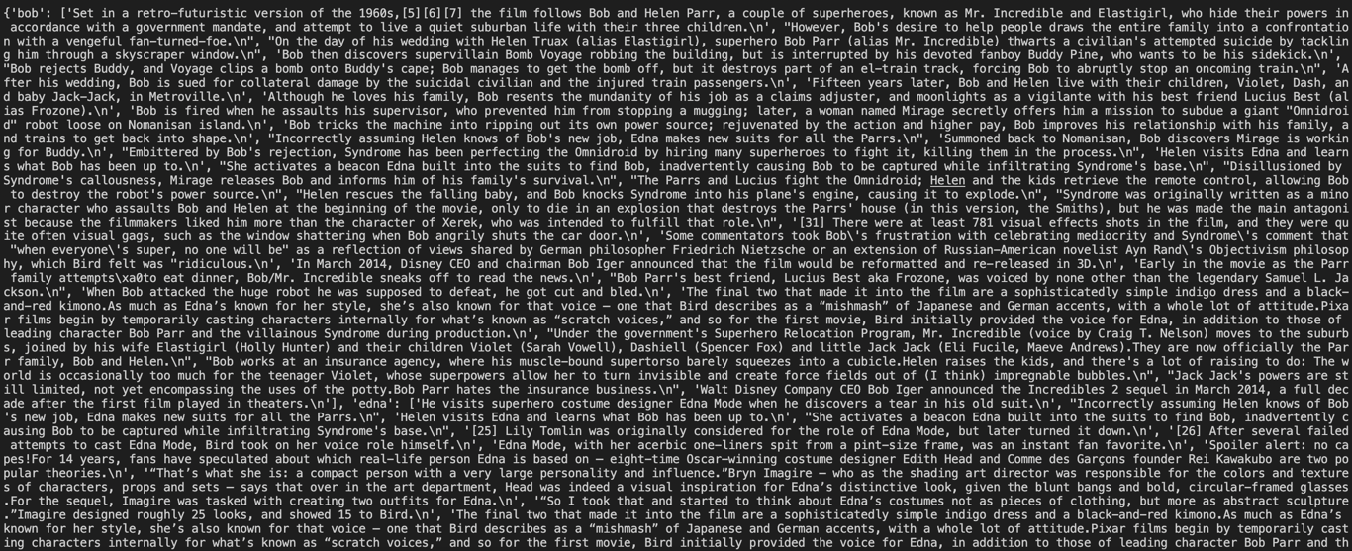

**Top 10 Terms:**

bob

edna

superhero

underminer

incredible

award

bird

fans

fantastic

million

**Example Dialog:**

Tell me about Bob

:: Although he loves his family, Bob resents the mundanity of his job as a claims adjuster, and moonlights as a vigilante with his best friend Lucius Best (alias Frozone).

Tell me about Edna

:: Edna Mode, with her acerbic one-liners spit from a pint-size frame, was an instant fan favorite.

Tell me more

:: Spoiler alert: no capes!For 14 years, fans have speculated about which real-life person Edna is based on — eight-time Oscar-winning costume designer Edith Head and Comme des Garçons founder Rei Kawakubo are two popular theories.

Who's brad bird?

:: The Incredibles was written and directed solely by Brad Bird, a departure from previous Pixar productions which typically had two or three directors and as many screenwriters with a history of working for the company.